Exploratory Data Analysis &
Data Visualization

Author:Brindha Devi
Project Type: Individual Project
Git Repo Link: https://github.com/brindhasp/CodeAlpha_EDA-Data-Visualization

EXECUTIVE SUMMARY:
The Exploratory Data Analysis (EDA) and Data Visualization project is a Python-based analytical system developed to analyze and visualize a dataset of quotes extracted from a public website. The project focuses on understanding patterns, distributions, and insights from structured data using statistical summaries and graphical representations.
Using Python libraries such as Pandas, Matplotlib, and Seaborn, the dataset is explored to identify key characteristics like author frequency and quote length distribution. The project demonstrates how raw data can be transformed into meaningful insights through analysis and visualization techniques.
This project highlights the importance of EDA in the data analytics lifecycle and shows how visual storytelling helps in better interpretation and decision-making.

PROJECT OVERVIEW:

Objective:
To perform Exploratory Data Analysis (EDA) on a quotes dataset and generate meaningful visual insights using Python data visualization libraries.

Scope:

• Load and analyze structured CSV dataset
• Perform data inspection using head(), info(), and describe()
• Analyze quote distribution by authors
• Calculate and study quote length patterns
• Visualize insights using bar charts and histograms
• Prepare dataset for advanced analytics or machine learning

Key Features

1. Data Inspection and Summary
The project uses Pandas functions such as head(), info(), and describe() to understand dataset structure, data types, and statistical summary.

2. Author-Based Analysis
Counts the number of quotes per author to identify the most frequent contributors in the dataset.

3. Quote Length Calculation
A new feature column (Quote_Length) is created to measure the length of each quote for distribution analysis.

4. Bar Chart Visualization
Matplotlib is used to generate a bar chart showing the Top 10 Authors by number of quotes.

5. Histogram Visualization
Seaborn histogram is used to visualize the distribution of quote lengths.

6. Clean and Structured Output
The project ensures the dataset is clean and ready for further machine learning or advanced analytics.

7. Data Analytics Ready Framework
The structured EDA workflow can be extended to larger datasets and real-world business analytics projects.

TECHNICAL IMPLEMENTATION:

Technology Stack:
• Programming Language: Python
• Data Analysis Library: Pandas
• Data Visualization: Matplotlib, Seaborn
• Development Environment: VS Code / Jupyter Notebook
• Dataset Source: quotes_data.csv (Scraped Dataset)

ANALYSIS PERFORMED:

1.Dataset Structure Analysis
- Total Entries: 10
- Columns: Quote, Author, Tags
- Data Type: String
- No missing values found

2.Top Authors Analysis
Albert Einstein appears most frequently in the dataset.
Other authors include J.K. Rowling, Jane Austen, Marilyn Monroe, and others.

3.Quote Length Distribution
The histogram shows variation in quote lengths ranging approximately between 50 to 130 characters.
Most quotes fall within the medium-length range.

Performance Metrics:
• Data completeness (No missing values)
• Accurate author frequency calculation
• Correct feature engineering (Quote Length)
• Clear visualization output
• Efficient processing with minimal memory usage

SOURCE CODE IMPLEMENTATION (Screenshot)
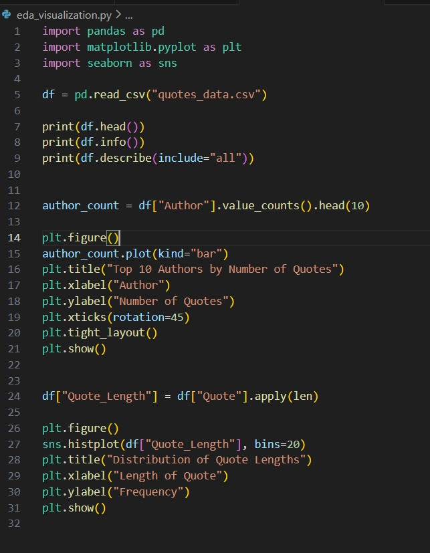

Extracted Job Result:

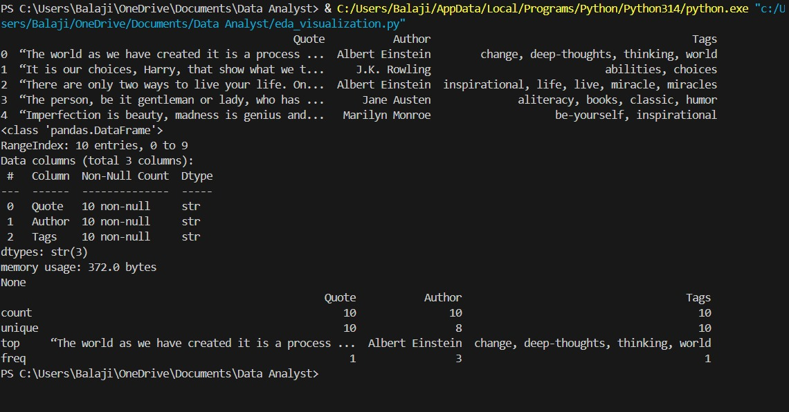

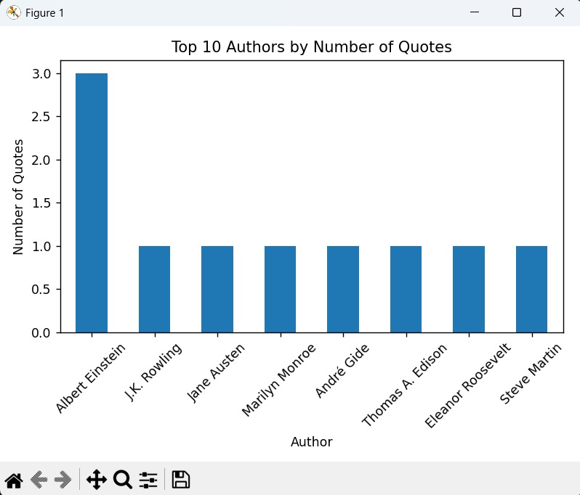

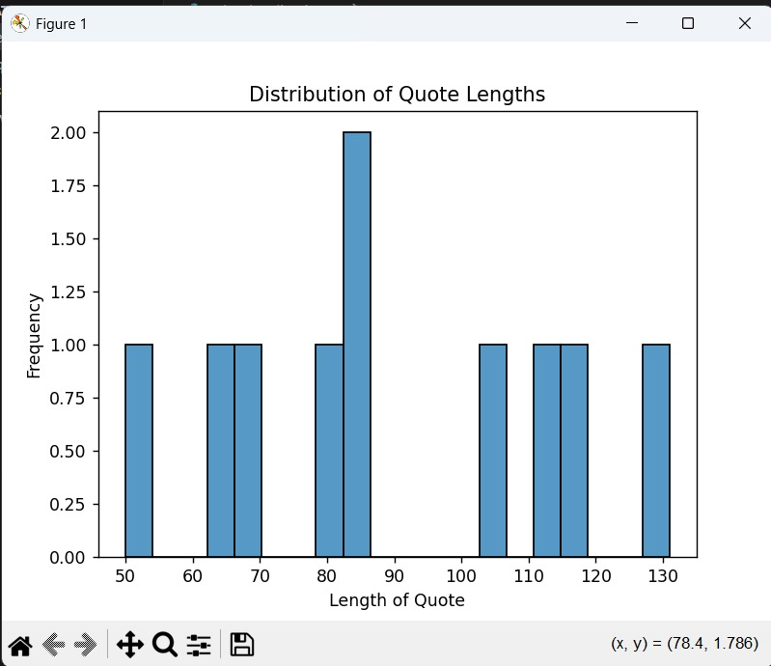

CONSTRAINTS:
• Small dataset size (10 records)
• Limited author diversity
• No advanced statistical analysis applied
• Static dataset (No real-time updates)

PROJECT IMPACT AND VALUE:

Immediate Benefits:
• Enhances understanding of EDA workflow
• Demonstrates visualization techniques
• Builds practical data analysis skills
• Strengthens Python data analytics foundation

Long-Term Potential:
• Integration with real-time web scraping
• Dashboard creation using Power BI / Tableau
• Text analytics and NLP integration
• Sentiment analysis on quotes
• Machine learning model development

CONCLUSION:
The Exploratory Data Analysis and Data Visualization project successfully demonstrates how structured datasets can be analyzed and interpreted using Python. By leveraging Pandas for data manipulation and Matplotlib and Seaborn for visualization, meaningful insights such as author frequency and quote length distribution were generated.

